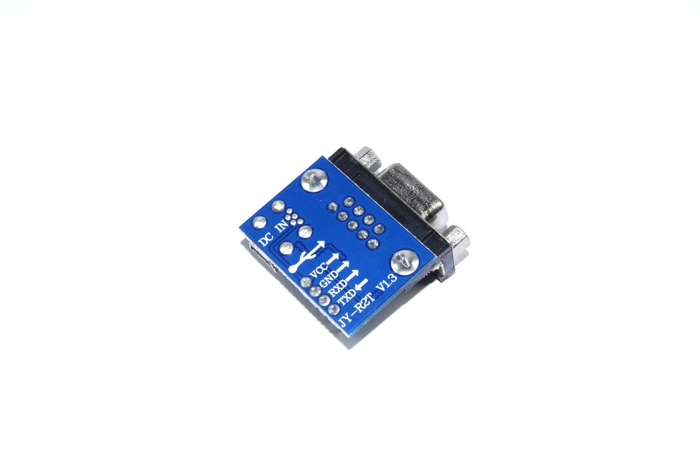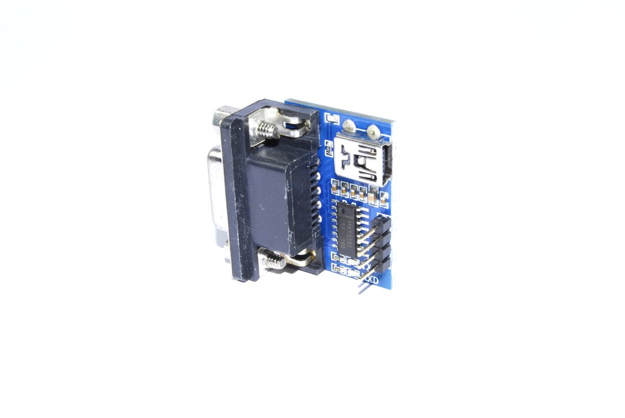

RS232 Serial Port Adapter Module JY-R2T V1.3 USB Game Joystick
Add to cart
ADD TO WISHLIST0

This is a MAX3232 breakout board, designed to allow the addition of a RS232 connection to your project. This module allows you to add a communication connection

Share this:
Share on Facebook Tweet on Twitter Share on Google+ Pin on Pinterest
FEATURES
- Drive Voltage:
3 - 5V
- Can be USB Powered:
Yes
- Characteristics:
PWR, RX and TX LEDs
- Communication Format:
Serial
- Communication Chipset:
MAX3232
- Baud Rate:
150K
- Pin pitch:
2.54
- Connectors:
RS232
- Operating Temperature:
-40°C to 85°C (unconfirmed)
- Number of Pieces:
1
- Included Items:
1 4pin 20cm F-F Jumper wire
DESCRIPTION
This is a MAX3232 breakout board, designed to allow the addition of a RS232 connection to your project. This module allows you to add a communication connection to your project, from programming small microcontrollers to a personalised computer keyboard.
Please do not hesitate to contact us if you require further information regarding the module's operation.
Pin | Description
VCC | 3-5V
GND | 0V
RXD | Receive
TXD | Transmit
CLK | Output clock
#include <SoftwareSerial.h>
//New serial port for my shield
SoftwareSerial Mx3232Serial = SoftwareSerial(7, 8);
//variabile
//char EchoChar = 'A';
char Str1[ ] = "s";
//String Str1 = " s";
//String Str1 = String(' s',HEX);
String Buffer; unsigned long T;
void setup() {
//pin7(RX) Input
pinMode(7, INPUT);
//pin8(TX) Output
pinMode(8, OUTPUT);
Mx3232Serial.begin(9600);
Serial.begin(9600);
}
void loop() {
//leggo dalla seriale(pin7)
//EchoChar = PortaSeriale.read();
//invio il dato letto
Mx3232Serial.print(Str1);
//Serial.println(Mx3232Serial.read());
Buffer = "";
T = millis();
while (millis() - T < 10) { // read all the chars on the serial
while (Mx3232Serial.available() > 0) {
Buffer += char(Mx3232Serial.read());
}
}
if (Buffer.length() > 0) { // transmit to Serial Monitor
Serial.print(Buffer);
}
delay(1000);
Serial.print(Str1);
}

https://forum.arduino.cc/index.php?topic=137447.0

